Design: Preferred DPM Allocation

Overview

New requirement
Enhance the CBOEdirect trade engine to allow for a Preferred DPM to receive an increased participation right. An order will be marked for Preferred DPM allocation with a firm acronym. In that case if a DPM from the firm is on the market, they will be allocated the best of preferred dpm, dpm complex or UMA allocation.

Implementation

Preferred DPM Allocation Strategy
Summary of Changes
- Introduced a new allocation strategy for Preferred DPM
- Introduced a new allocation strategy code for Prferred DPM AllocationStrategyCodes (19)
- The code has to be set up using trading property (see script changes) at a class level or for all classes in a session

- IDL Changes
- server/constants.idl
- Class Changes
- ./Java/impls/com/cboe/businessServices/orderBookService/AllocationGroup.java
- ./Java/impls/com/cboe/businessServices/orderBookService/AllocationGroup.java
- ./Java/impls/com/cboe/businessServices/orderBookService/AllocationPreferredDPMStrategyElement.java
- ./Java/impls/com/cboe/businessServices/orderBookService/AllocationStrategyFactoryImpl.java
- ./Java/impls/com/cboe/businessServices/orderBookService/DpmRightsSpecification.java

- Script Changes
- ./scripts/setTradingProperties
setTradingProperty W_MAIN default AllocationStrategies "0=1;4;19,2=1;4;12;7,3=14"

Create a new Trading Property ‘Preferred DPM Rights Rate’ and set it initially to 2/3 (0.66667)
Summary of Changes
- Introduced a new trading property “PreferredDPMRightsRate” initially set to 0.67
  - IDL Changes
- ./idl/TradingProperty.idl
- ./idl/TradingPropertyService.idl
- Class Changes
- ./Java/impls/com/cboe/internalBusinessServices/tradingPropertyService/TradingPropertyPublisherImpl.java
- ./Java/impls/com/cboe/internalBusinessServices/tradingPropertyService/TradingPropertyServiceLocalImpl.java
- ./Java/impls/com/cboe/internalBusinessServices/tradingPropertyService/TradingPropertyServiceLocalNullImpl.java
- ./Java/impls/com/cboe/internalBusinessServices/tradingPropertyService/persistence/PDPMRightsRate.java
- ./Java/impls/com/cboe/internalBusinessServices/tradingPropertyService/persistence/TradingPropertyHomeImpl.java
- ./Java/impls/com/cboe/proxy/internalBusinessServices/TradingPropertyServiceCacheManager.java
- ./Java/impls/com/cboe/proxy/internalBusinessServices/TradingPropertyServiceCachedProxy.java
- ./Java/impls/com/cboe/proxy/internalBusinessServices/TradingPropertyServiceProxy.java
- ./Java/impls/com/cboe/proxy/internalBusinessServices/TradingPropertyServiceRoutingProxy.java
- ./Java/impls/com/cboe/server/events/TradingPropertyConsumerImpl.java
- ./Java/impls/com/cboe/server/events/TradingPropertyPublisher.java
- /Java/interfaces/com/cboe/interfaces/internalBusinessServices/tradingPropertyListeners/PreferredDPMRightsRateListener.java
- Script Changes
- ./scripts/setTradingProperties
setTradingProperty W_MAIN default PreferredDPMRightsRate 0.67

User Firm Affiliation Changes
Summary of Changes
- Introduced a new database table for a relationship between affiliated firms and sbt users
- Introduce new persistence class to represent this relationship
- Introduce get/set method in UserMaintenanceService
- Introduce couple of methods in ‘CacheUpdate’ consumer and event channel to have UserMaintenanceCachedProxy up to date on the business cluster
- Have a flag for CAS rollout issue which would not publish until all the changes have been rolled out.

a. IDL Changes
- /idl/user.idl
- ./idl/UserMaintenanceService.idl
- ./idl/consumers.idl
- Class Changes
- ./Java/interfaces/com/cboe/interfaces/domain/user/UserFirmAffiliation.java
- ./Java/interfaces/com/cboe/interfaces/domain/user/UserFirmAffiliationHome.java
- ./Java/persist/com/cboe/domain/user/UserFirmAffiliationHomeImpl.java
- ./Java/persist/com/cboe/domain/user/UserFirmAffiliationImpl.java.
- ./Java/impls/com/cboe/consumers/eventChannel/CacheUpdateConsumerIECImpl.java
- ./Java/impls/com/cboe/consumers/eventChannel/CacheUpdateConsumerImpl.java
- ./Java/impls/com/cboe/consumers/eventChannel/CacheUpdateConsumerProxy.java
- /Java/impls/com/cboe/server/events/CacheUpdateConsumerImpl.java
- ./Java/impls/com/cboe/server/events/CacheUpdatePublisher.java
- ./Java/impls/com/cboe/tools/CacheUpdateEventStub.java.
- ./Java/impls/com/cboe/businessServices/userService/UserServiceImpl.java
- ./Java/impls/com/cboe/businessServices/userService/UserServiceNullImpl.java
- /Java/impls/com/cboe/proxy/businessServices/FirmServiceCachedProxy.java
- ./Java/impls/com/cboe/proxy/businessServices/UserServiceCachedProxy.java
- ./Java/impls/com/cboe/proxy/internalBusinessServices/FirmMaintenanceServiceCachedProxy.java
- ./Java/impls/com/cboe/proxy/internalBusinessServices/UserMaintenanceServiceCacheManager.java
- ./Java/impls/com/cboe/proxy/internalBusinessServices/UserMaintenanceServiceProxy.java
- ./Java/impls/com/cboe/proxy/internalBusinessServices/UserMaintenanceServiceRoutingProxy.java
- Script Changes (DB Changes)
- ./sql/UserFirmAffliation.sql

Invoking Preferred DPM Strategy and Locating a Preferred DPM
Summary of Changes
- The order will be marked with P:<Firm Acronym> to indicate allocation to preferred DPM or eDPM
- The firm acronym is used to get the users that if on the market are considered preferred dpm
- Currently com.cboe.interface.domain.AllocationTradeContext is used to determine the correct allocation context (Opening, Regulat or Quote Trigger). This context is passed to the Order Book to use the appropriate allocation strategy.
- The same interface will be used to set the Preferred DPM context and the preferred DPM’s firm acronym.

  - Class Changes
- ./Java/impls/com/cboe/businessServices/tradeService/AllocationTradeContextImpl.java
- ./Java/impls/com/cboe/businessServices/tradeService/TradeServiceImpl.java
- ./Java/interfaces/com/cboe/interfaces/domain/AllocationTradeContext.java
- ./Java/interfaces/com/cboe/interfaces/domain/TradingClass.java
- ./Java/impls/com/cboe/internalBusinessServices/productStateService/TradingClassHomeImpl.java
- ./Java/impls/com/cboe/internalBusinessServices/productStateService/TradingClassImpl.java

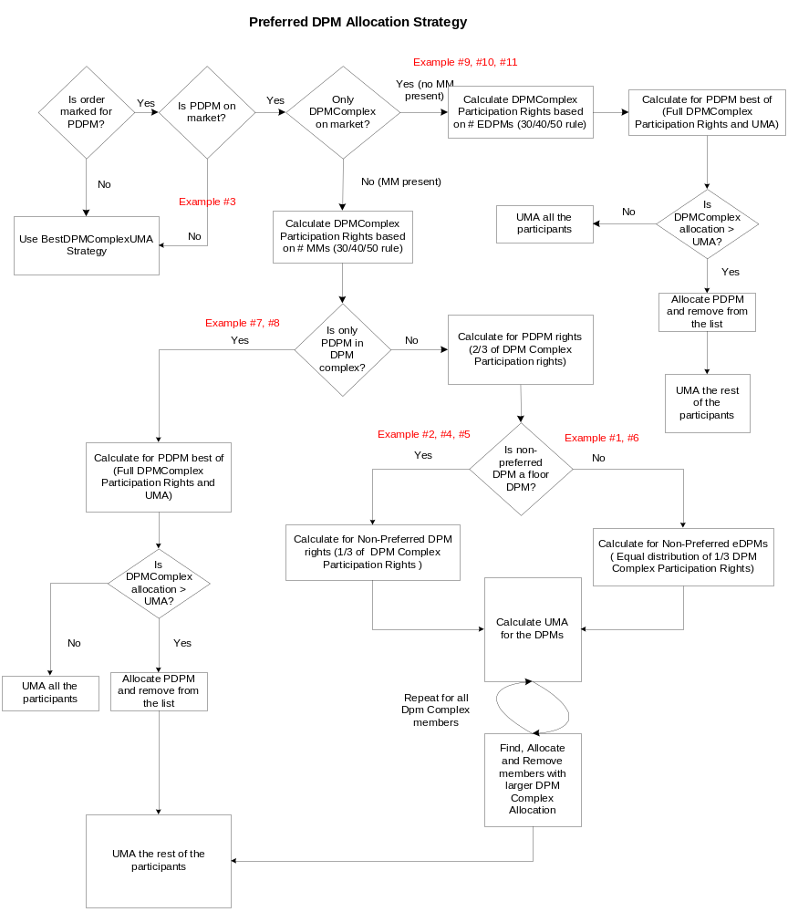

Appendix B: Preferred DPMs Examples

